Alexander Baldree
09/03/26
Module 5.2 Assignment
CSD440

GitHub Link:
https://github.com/Panda-Alex21687/CSD440

File XAMPP:
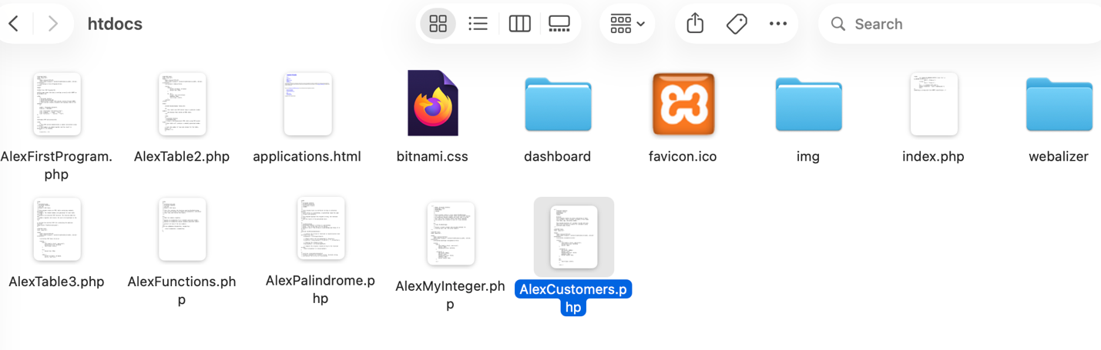

Output:
